國立高雄科技大學

國際管理碩士學位學程

碩士論文

中文題目(Chinese Title)

英文題目(English Title)

研究生: Chinese name/English name

指導教授: 博士

中華民國 年 月

中文題目(Chinese Title)

英文題目(English Title)

研究生：Chinese name/English

指導教授:Teacher Chinese name博士English name

國立高雄科技大學

國際管理碩士學位學程

碩士論文

A Thesis

Presented to

International Master of Business Administration Program

National Kaohsiung University of Science and Technology

in Partial Fulfillment of the Requirements

for the Degree of

Master of Business Administration

in

International Master of Business Administration

June 2026

Kaohsiung, Taiwan, Republic of China

中華民國 年 月



**Notes: This page (Committe member 's Consent) should be signed after thesis defense then add this page when you upload online and print out to the library**

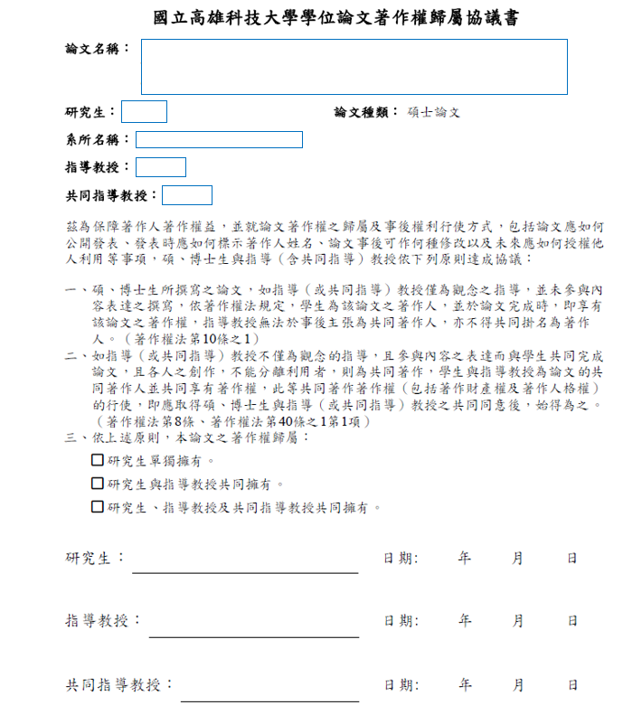

**Notes: This page should be signed after thesis defense then add this page when you upload online and print out to the library**

××××××××（中文題目）×××××××××

學生：×××x 指導教授：××××

× ×××

國立高雄科技大學

國際管理碩士學位學程

摘 要

-----------------------------------------------------------------------------------------------------------------------------------------------------------------------------------------------------------------------------------------------------------------------------------------------------------------------------------------------------------------------------------------------------------------------------------------------------------------------------------------------------------------------------------------------------------------------------------------------------------------------------------------

××××××××（English Title）×××××××××

Student: English name Advisors: Teacher English name

Dr.××××

International Master of Business Administration Program

National Kaohsiung University of Science and Technology

**ABSTRACT**

------------------------------------------------------------------------------------------------------------------------------------------------------------------------------------------------------------------------------------------------------------------------------------------------------------------------------------------------------------------------------------------------------------------------------------------------------------------------------------------------------------------------------------------------------------------------------------------------

**ACKNOWLEDGMENTS**

----------------------------------------------------------------------------------------------------------------------------------------------------------------------------------------------------------------------------------------------------------------------------------------------------------------------------------------------------------------------------------------------------------------------------------------------------------------------------------

**TABLE OF CONTENTS**

摘要…………………………………..…………………………………………………….…i

Abstract…………………………………………………………………………...………..…ii

Acknowledgements……………………………………..………………………...……….…iii

Table of contents……………………………………………………..………….………..… iv

List of Tables………………………………………………………….…….……………..…vi

List of Figures…………………………………………………………….………………… vii

**CHAPTER1:INTRODUCTION**……………………………………………………….……1

1.1 Introduction. ……………………………………………………………….………….......1

1.2 Research motivation ……………………………………………………………………....3

1.3 Statement of the problem ………………………………….……………………………...5

**CHAPTER 2: LITERATURE REVIEW** ……………………………….……………….….6

2.1 Introduction………………………………………..…………………..…………………… 7

2.2 Virtual tourism………….………………………………………..…………….…..………. 8

**CHAPTER 3: METHODOLOGY** ……………….……….…….………………………….… 9

3.1 Introduction……………....………………..……………………………………….............. 10

3.2 Hypothesis and the Conceptual Framework……………………………..……………….....11

**CHAPTER 4: FINDINGS** ..……………..…………………………………………………… 13

4.1 Introduction……………………..………………………………………….……….………

4.2 SPSS analysis…………………………………………………………...….…….…………

4.3 Tawain Virtual Tourism…………………………….……………………..…...……………

**CHAPTER 5: CONCLUSION AND RECOMMENDATIONS** …….………………………

5.1 Summary………………………………………………..…………………………...............

5.2 Implications……………………………………………………..…….……………..………

5.3. Research limitations and future research directions………………………………………..

**References** ………………………………………………………………….…………………..

**Appendix** …………………………………………………………………………….................

**LIST OF TABLES**

Table 3.1: Marketing Strategy ………………………………………………………………

Table 3.2: Marketing planning.............…………………………..………….…………….

**LIST OF FIGURES**

Figure 3.1: Study flow chart ………………………………………..……………

Figure 3.2:Research framework ………………………………………..……………

**CHAPTER 1**

**INTRODUCTION**

1.1 Introduction

While corporeal patterns of mobility continue to increase, virtual tourism has become a widespread social practice in contemporary society. Virtual tours have been widely used in the promotion and selling of tourist sites and experiences, especially within the context of governmental touristic websites.

**CHAPTER 2**

**LITERATURE REVIEW**

2.1 Introduction

Ontological studies concerning the nature and meaning of reality have been the object of philosophical disputes since antiquity. From Plato's and Aristotle's ideas of ‘universals’ to Kant's and Hegel's idealist thought, traditional philosophical studies have produced diverse epistemological stances concerning the relationship between reality and our knowledge of/what is thought of as reality. In this respect, various branches of contemporary philosophical realism contend that reality transcends the realm of our physical experience (Rescher, 2010).

**CHAPTER 3**

**HYPOTHESIS AND METHODOLOGY**

3.1 Introduction

This research employs virtual ethnography (Hine, 2000), also known as netnography (Kozinets, 2010). Kozinets (2010, p. 60) defines netnography as ‘participant-observational research based in online fieldwork’. Like ethnography, netnography is a research approach that incorporates different data collection methods and techniques, such as participant observation and in-depth interviews.

**CHAPTER 4**

**QUALITATIVE AND QUANTITAVE ANALYSIS**

4.1 Introduction

As Second Life provides opportunities for people to create ‘customized’ avatars before they enter the virtual world, part of the findings of this study unveils how the women interviewed chose their avatars before they travelled to virtual tourist destinations. For all the respondents the choice of the avatar involved a long and complex decisional process.

**CHAPTER 5**

**CONCLUSIONS AND RECOMMENDATIONS**

5.1 Introductions

Making cycling an attractive option for a wide range of the population is a key policy aim of the current cycling strategy for London (Greater London Authority, 2013), and achieving this aim would be expected to help maximise the potential benefits of cycling for health and health equity (Marmot, 2010; Woodcock et al., 2014).

**REFERENCE**

•Beecham, R., Wood, J., 2014. Exploring gendered cycling behaviours within a largescale

behavioural dataset. Transportation Planning and Technology, vol. 37, issue 3, 83–97.

•Fishman, E., Washington, S., Haworth, N., 2013. Bike share: a synthesis of the literature.

Transport Review, vol. 33, issue 2, 148–165.

•http://www.presotea.com (retrieved 2016/04/30)

**Appendix A: The Survey**

Dear Participants:

The purpose of this study is to collect information regarding the effectiveness change and adaptation for from Chain restaurants to The Tawain. This survey will take about 20 minutes to complete. All the information gathered will be kept strictly anonymous.Your participation in this survey is voluntary. If you decide not to take this survey, please feel free not to participate.