- Student Feedback

Name: Claire陳氏水仙 Student ID: F108121110
Feedback
Overall, the internship was good and successful. I have learn many things form the company even from the small things. I am able to know more about finance, which I have not, try before and it is an amazing experience for me.
Name: Truong Ngoc Hoa (Annie) 張玉華 Student ID: F109121118
Feedback
I learned many useful and realistic things from the internship that enrich my experience and future works. HFC is a well – known company in finance in Taiwan and its business operation is professional. We were received lots of support from enthusiastic staffs as well as departments during the internship time and we really appreciate it.
Suggestion
Even though HFC tried the best to convey information to us in English but there was still remaining language barrier that a few departments could not speak English well.
The company should innovate the paper and information system with bilingual Chinese – English. This is a first significant step to reach abroad market. It facilitates training international staffs and the business in the future.
The schedule was tight and quite stressful in the first week, it should be designed more suitable for the next internships. Once HFC has a clear plan to enter the new market in the future, the internship schedule and program should be restructured. For example, after the first week understanding the company overall and its operation, students could choose their favorite department to approach and understand more deeply the works in the department as well as learn realistic cases.
Name: HONG SOVANNDA (洪萬達) Student ID: F108190109
Feedback
his is the good internship for me and I really appreciate to the NKUST’s management, and staff who arrange this program with HFC. It’s very value to me and others student who have attended it, it has given so many knowledge and experience for understanding about the finance industry, how they reach their objectives and goal.
Suggestion
I would like to ask for continuing to arrange this internship program to the next students to have chance for this special training and exchange language with each other. By the way, I also suggest for the finance preparation for the student before joining the program.
Name: Nimol Touch (倪塔奇) Student ID: F109121104
Feedback
Overall of the internship was good and we have learned from many departments across the company. There’s an enthusiasm from the company’s employees and managers to engage in our program.
Suggestion
Three weeks is a short period of time to show in our CV for the future job. If three weeks for multiple times will be good.
Others
The representatives will come to be our school as guest speakers in March, that is a good news for other students to learn about the company.

2.Photo
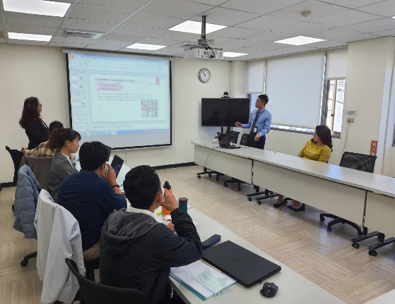 | 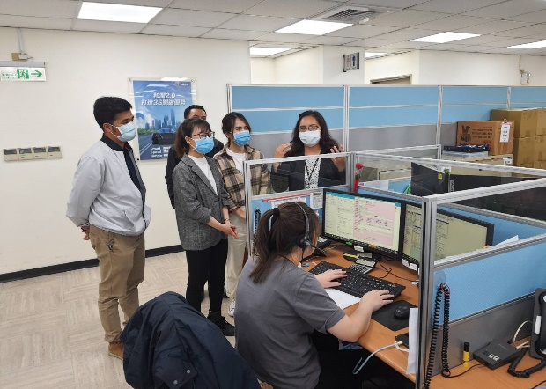
Photo description：Credit assessment department | Photo description：Credit assessment department
 | 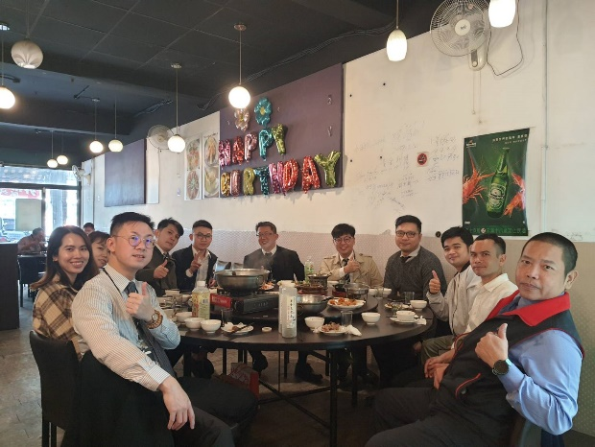
Photo description：Visit truck dealer | Photo description：Have lunch with Sale department
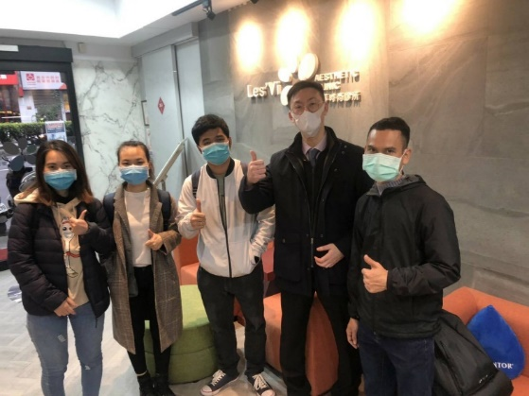 | 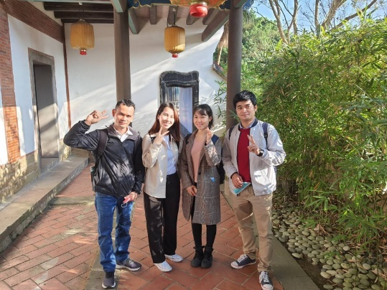
Photo description：Visit Hotai’s customer (clinic) | Photo description：Sight seeing
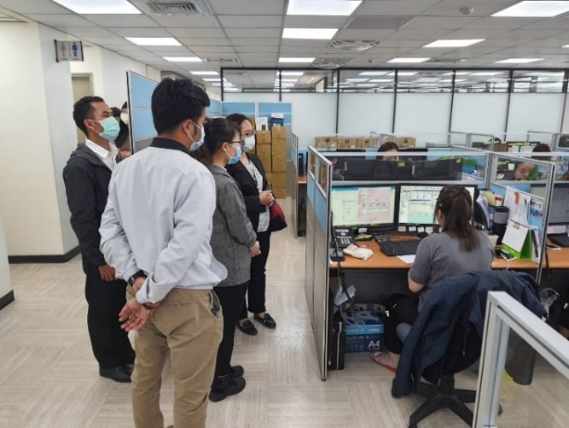 | 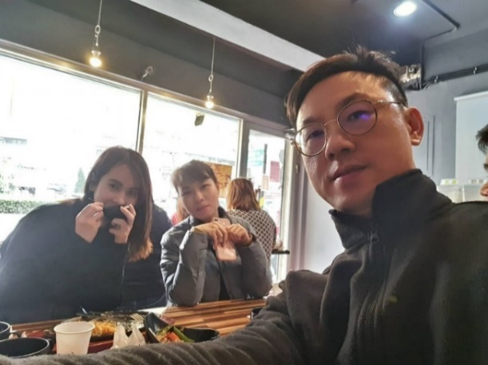
Photo description：Visit working environment | Photo description：Lunch break
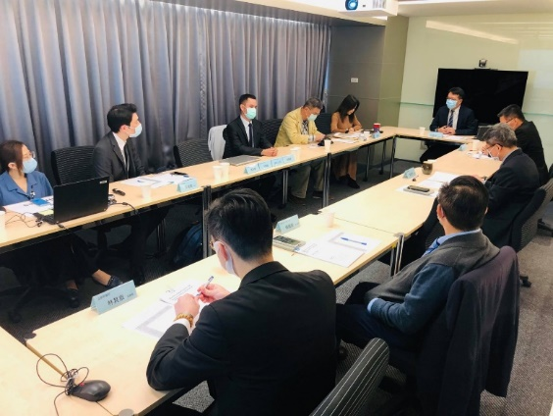 | 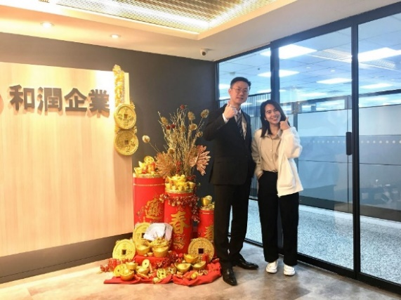
Photo description：Oral presentation |  | Photo description：Last day in headquarter
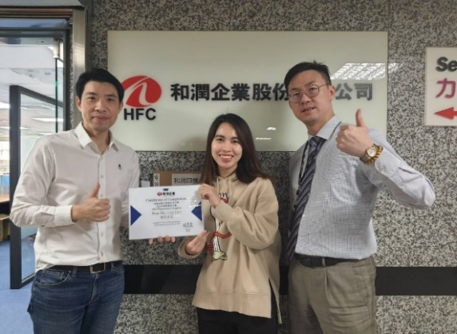 |  | 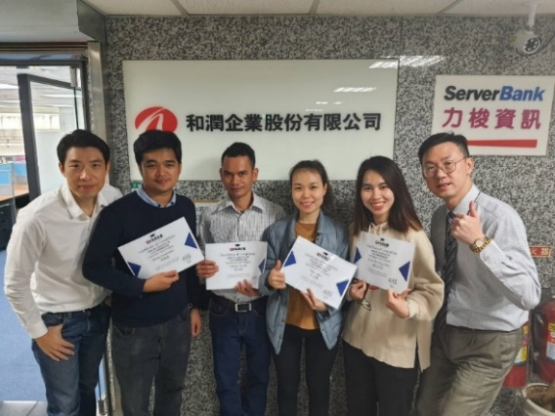
Photo description：Last day of Internship and receive certification |  | Photo description：Last day of Internship and receive certification

